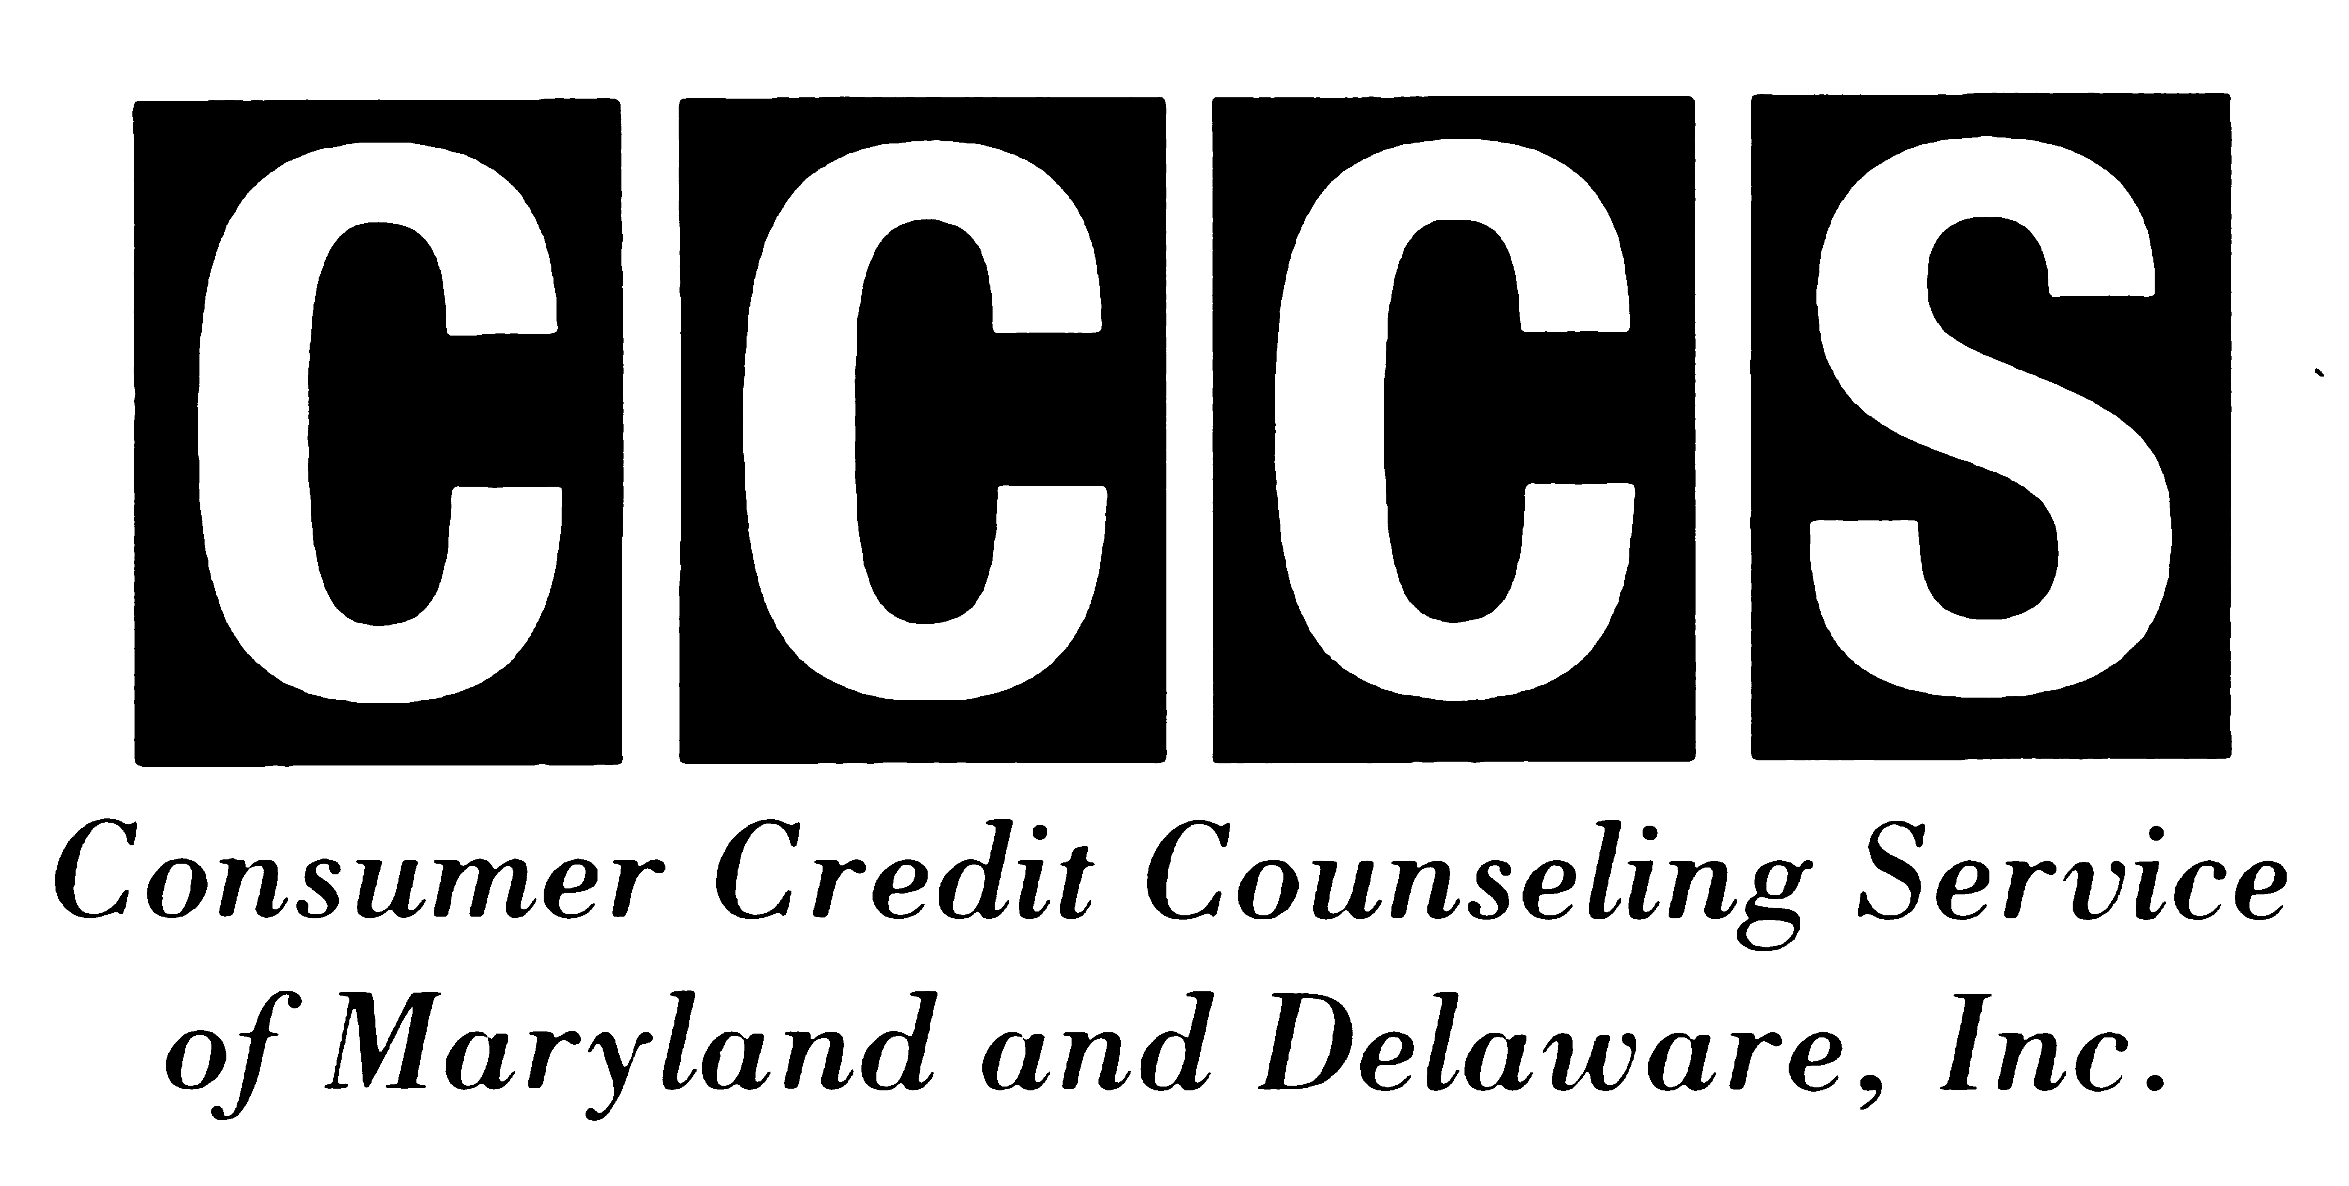
FOR IMMEDIATE RELEASE Contact Information:
April 10, 2011 NANCY STARK
410.357.0614 (phone)
410.357.0613 (fax) nstark@mind2medias.com
Helping people help themselves through Education, Financial Counseling and Debt Repayment
FINANCIAL EXPERTS SHARE IDEAS ON HOW TO USE YOUR TAX REFUND
Are you expecting a tax refund this year? If so, you may be in luck. Based on IRS figures from mid-March, refunds are averaging about $3,000 each. With an adjustment for inflation, that’s up almost $600 over five years ago. And there are more options for using your refund to promote your family’s financial security than ever before. According to Jim Godfrey, President and CEO of local nonprofit Consumer Credit Counseling Service of MD & DE (CCCS), “it makes sense to have a tax refund game plan. If you know you’re going to receive a one, think about how to use it wisely. That way, you won’t be tempted to go on a spending binge and buy items you don’t really need.”
Many Americans have already taken this advice to heart. In a recent Harris Poll conducted with 2,469 adults, nearly half of those expecting a refund said they plan to use it to reduce their debt, and 44 percent plan to save the money.
Spending Strategies. Baltimore CASH Campaign Director Sara Johnson supports this approach, noting, “When asked, we usually recommend that local residents spend some and save some. This year, many of our clients say they plan to use their refund to cover current or past due bills. If you’re living on the edge, like many of us are, paying down credit cards or other debts can help you gain increased financial stability.”
Godfrey agrees. He recommends that consumers use a portion of their tax refund to pay the balance on whichever credit card has the highest interest rate. “If you can't completely pay off all your credit cards, at least make a sizeable payment on one with a high rate. That way, you’ll still reduce your interest costs. Using your refund to pay off a balance on a credit card with an 18% interest rate is like earning 18% on your investments. It represents an extremely good value.”
Saving Strategies. Maryland CASH Campaign Director Robin McKinney says, “When it comes to tax refunds, we recommend that you pay yourself first. If you haven’t already set up an emergency fund, this is your chance. By using a portion of your refund to open a savings account, you help insure that you’ll have a nest egg if the car breaks down, you run into medical bills, or experience job loss. It can make a big difference when unexpected expenses or life situations arise.”
McKinney notes that a traditional savings account is just one of the ways that a tax refund can be used to save. “You can also use your refund to buy savings bonds or open a CD. If you use it before April 15 to make an extra payment on an IRA account, you may even qualify for a retroactive tax deduction.”
This year, the IRS is making it easier than ever for consumers to use their tax refunds to save. Through Form 8888, they can buy savings bonds for themselves or their children or grandchildren right when they file their taxes. They also can designate that their Federal tax refund be deposited in multiple accounts (savings, IRA, CD, etc.) “To do this, you need to know your bank’s routing number and the number for each of the accounts,” McKinney explains. “Then it’s really simple. You or your preparer just fill out the Form 8888, and it is submitted as part of your tax return.” Maryland and Delaware residents also can request that their State tax refund be deposited into multiple accounts.
How to Speed Up Your Tax Refund. Consumers who hope to receive a swift tax refund should avoid signing up for the refund services they see advertised that promise “Fast Cash” or “Instant Refunds.” Godfrey emphasizes, “These services are actually refund anticipation loans, where you borrow against your refund. They often involve high fees and can leave you with a substantially smaller refund. For a fast refund, file early, use electronic filing, and request direct deposit. These strategies facilitate the refund process and make it possible for you to keep your entire refund.”
Johnson and McKinney second this recommendation. According to Johnson, “Refund anticipation loans often strip 30-40% from taxpayers’ refunds. These companies charge exorbitant fees, and interest rates of 300% are not uncommon.”
McKinney stresses that it’s important to “ask tax preparers about the fees they charge for preparation and refund processing before they begin work on your return. Also definitely use electronic-filing or e-file for short. This will save you a lot of time given the IRS has to manually input all the information from a paper return before it can process your refund.” Consumers who file early, file electronically, and use direct deposit are likely to receive their refunds in a matter of days.
Parting Resources and Advice. Tax preparation is rarely easy even if you expect to receive a refund. If you earn less than $49,000 a year and live in Maryland or Delaware, free tax preparation help is available through April 18:
The Baltimore CASH Campaign website at www.bmorefreetaxes.org includes a location list for its tax preparation sites. If you are a Baltimore City or Baltimore County resident, visit the website or call 410-234-8008 to register for an appointment.
Residents throughout Maryland can obtain free tax preparation resources through the Maryland CASH Campaign’s partners across the state. Maryland CASH’s website (www.mdcash.org) includes helpful tax filing advice and a State-wide list of free tax preparation sites. To register for a tax preparation appointment through Maryland CASH, visit its website or call 1-800-492-0618.
Delaware residents receive free tax preparation help via the Delaware Earned Income Tax Credit Campaign. Visit its website or call (www.eitcdelaware.net / 302-655-0803) for further information.
In closing, Godfrey notes, “Tax time is never fun, but it offers consumers a golden opportunity to examine their financial habits and make positive changes. Those who plan and use their tax refunds well are likely to be in a financially stronger position when tax time rolls around again next year.”
####
Consumer Credit Counseling Service of MD & DE, Inc. (CCCS) is an accredited nonprofit agency that has served the local community since 1966. CCCS is dedicated to helping individuals and families resolve their financial problems. We promote the wise use of credit through education and confidential budget, money management counseling, and housing counseling. MD State License #14-01.

